

|  |
| --- |
| mCashier |
| PRODUCT MANUAL AND  TROUBLESHOOTING GUIDE |

Product manual 4

What is mCashier? 4

Why mCashier? 4

Get Started 5

How to sign up for Moble Cashier Service 5

How to set up Mobile Cashier 6

Application menu tree 10

How to use mCashier 10

Conducting card payment 10

Additional functionalities 12

Accept Cash 12

Cash Drawer treatment 12

Track payment activity. 15

Receipts 17

Send Receipts 17

Resend Receipts 17

Print receipts 18

Mobile Cashier application connectivity charges: 19

Multiple mCashier accounts 19

Accepted Cards and Fees 19

Fees and pricing 19

Bank Account and Deposits 20

Security 20

Hardware 20

Physical and Network Security 20

Web and Client Application Security 21

Organizational Security 21

FAQs: 23

Q: Am I eligible to apply for mCashier? 23

Q: Who is offering mCashier service: 23

Q: Is your service secure? 23

Q: Do I need to have a bank account with NBAD in order to use this service? 23

Q: What card brands and card types do you accept? 23

Q: What are your fees: 23

Q: How does “Pay with Cash” option work? 24

Q: How ForEx rates are determined? 24

Q: How does “Pay with phone number” works 25

Q: What do I do to keep my mCashier advices function properly: 25

Q: Customer does not feel comfortable to give SMS/email address for the receipt 25

Q: Customer have not received receipt (via SMS or email) 25

Q: Why am I not receiving deposits? 25

Q: When will my money be deposited? 26

Q: I cannot I sign in to my merchant web portal 26

Q: Why can't I activate my account to accept payment cards? 26

Q: Where can I use mCashier? 26

Q: My card reader/printer is not working -where I can replace it. 26

Q: where do I get paper for printing receipts: 26

Troubleshooting: 27

Delayed or Pending mCashier Activation 27

Password Troubleshooting 27

Reset Merchant Password for the online mCashier portal 27

Reset Merchant Password in the App 27

mCashier card reader Troubleshooting 28

Error: No device connected/Mobile app failed to start Bluetooth 2.0/Please pair the device first 29

Error: BAD SWIPE: Card reader cannot read/fill certain cards 33

Troubleshoot Merchant Application performance 33

Payment Troubleshooting 35

Declined Cards 35

Void Payment 35

Handling refund 35

Customer have not received receipt via SMS/email 37

Report was not delivered to requested email address. 37

Transaction Connectivity Disruption 38

Pending Charges 38

Troubleshoot Merchant Bluetooth Receipt Printer 39

Error: Device is not switching on 39

Error: Printer is not getting paired with mobile device. 40

Error: Device is not printing. 40

Error: Bad printing quality 41

Error: Receipt is not coming smoothly, paper jam 41

Error: OS on device is < 2.3.3 ( GingerBread) 41

# Product manual

## What is mCashier?

mCashier is an innovate service for business customers enabling them to accept debit and credit card based payments via smart phone and connected Card reader. Product is offered in partnership with NBAD.

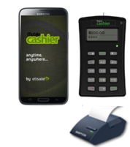

## Why mCashier?

It's simple, quick and secure -- for Merchants and customers.

mCashier card reader fits in the pocket so Merchant is always ready for business. He/she needs to download Etisalat Mobile Cashier application on Merchant phone, pair Bluetooth card reader and start accepting credit/debit cards payments.

Affordable and simple pricing:

No hidden fees – pay 299 AED for the device upfront or select convenient monthly payment options that do not put strain on Merchant business cash flow (27 AED monthly for 12 months) No hidden fees or connectivity charges -guaranteed.

Get Paid Fast

Funds from card payments are deposited directly into Merchant bank account within one-to two business days.

Safe and Secure

Mobile Cashier is EMV approved and PCI-DSS compliant. This bank-level security starts at the moment the card is inserted in the reader and continues through the entire length of transaction.

Grow business

Track sales data directly from tufMerchant phone in real time and make more informed business decisions.

Receipts

No more fumbling for pen or sorting through paper receipts. Customers can receive electronic receipts via SMS or email instantly

Easy to use

To make Merchant experience more convenient, Mobile Cashier is available in English, Arabic, Hindi, Urdu, Tagalog and Russian.

## Get Started

In order to start accepting credit and debit card payments with mCashier Merchant needs to have the following:

1. Etisalat active Wasel or Postpaid GSM account
2. Current bank account
3. Signed Merchant agreement for mCashier service with NBAD
4. mCashier card reader
5. mCashier App
6. Android phone

## How to sign up for Moble Cashier Service

1. Visit selected Etisalat Business Centers or participating Partner Facilities (list TBD) and bring the following documents:

|  |  |  |  |
| --- | --- | --- | --- |
| Document | Type | Requirements |  |
| 1. Valid trade license | copy | All |  |
| 1. Chamber of Commerce Registration Certificate | copy | All |  |
| 1. Passport & Visa of All Partners & Authorized signatory(s). | copy | All |  |
| 1. Bank statement | original | All |  |
| 1. Copy of court authenticated Power of Attorney | copy | Where applicable- if local partner did not sign |  |
| 1. Memorandum & Articles of Association | copy | For LLC |  |
| 1. Signature Verification Document (Aitmaad Al Tauqiya or Labour Dept. Sign. Ver. Card). | copy | Where applicable |  |
| 1. Partnership deed or any other legal supporting documents (authenticated by Court). ( | copy | For Partnership Company |  |
| 1. Service Agents & De-facto owner’s Agreement copy. | copy | In case of Professional license |  |
|  |  |  |  |

1. Sign contract with the Bank for provisioning of mCashier services. State current bank account details. This is very important, as this is where Merchant money will be deposited. Funds from card payments are deposited directly into Merchant bank account within one-to two business days.
2. Purchase a card reader. There is a choice of paying 299 AED upfront or selecting 12 month installment plan (27 AED per month). Etisalat Mobile Cashier is EMV approved and PCI-DSS compliant. This bank-level security starts at the moment the card is inserted in the reader and continues through the entire length of transaction.
3. Merchant will receive notification once the Bank approves Merchant application. We estimate it to be within 48 hours timeframe.
4. Install Mobile Cashier application on mobile phone. Etisalat will send merchant an SMS with link to download the Mobile Cashier Application.
5. Merchant account will be activated and Merchant will be asked to change Merchant password. Default password is “1234”.

## How to set up Mobile Cashier

Click on the link to download the Mobile cashier application. Please note that application only supports Android OS

The mCashier app is designed to run on Android devices version OS 2.3.3 (GingerBread) and up and requires Bluetooth v 2.1 and up to connect to mCashier Bluetooth card reader.

To check Android software version number, go to Settings app > About device > Android version.

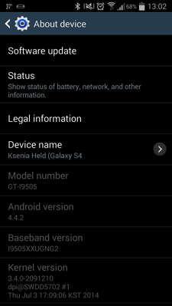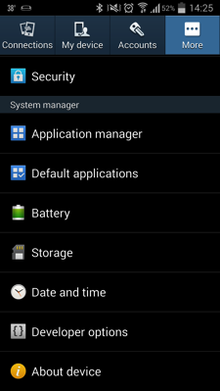

The process to update the software on each Android device is different. If Merchant device is not running 2.3 or higher, check with Merchant manufacturer or carrier for upgrades.

Click on the link to download the Mobile cashier application. Files are usually saved in Download folder. To start installation, select Mobile Cashier application and double click to open it.

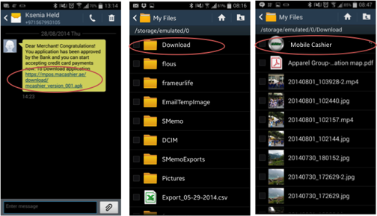

Allow the application to get installed by checking the box (do not worry application is safe and secure and Merchant will not be charged for download)

Click next and follow the installation to complete

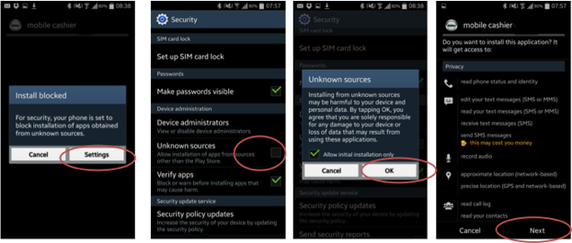

First time application usage requires accepting terms and conditions. Please enter password. Application will send authentication SMS (SIM card is being authenticated as a lawful user). It might take some time.

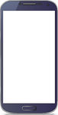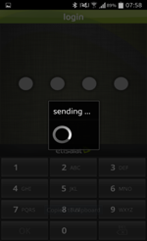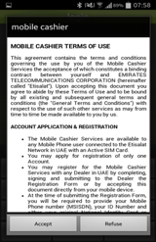

The application will work using WIFI, data or SMS. Application will fall back to SMS in case the coverage is not good. Merchant can change the transport media any time by changing Transport medium Mode on the Settings menu

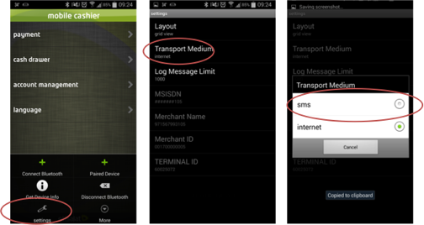

Pairing of Mobile Cashier device (done one time during initial set up)

1. Take mCashier device out of the case
2. Charge it before use. Lightly press on the power button. The screen will boot and show STANDBY. Press on Bluetooth button until the blue light comes. Device will show BT Pairing.

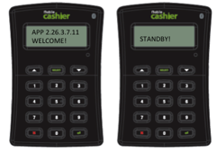

1. Open Etisalat Mobile Cashier application on Merchant Mobile phone. Select the application menu and Select “Connect new Device option”.

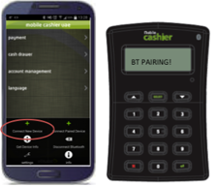

1. Confirm the passkey on both mCashier device and mobile phone. Pairing is complete.

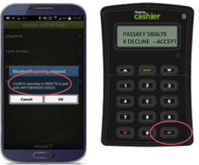

## Application menu tree

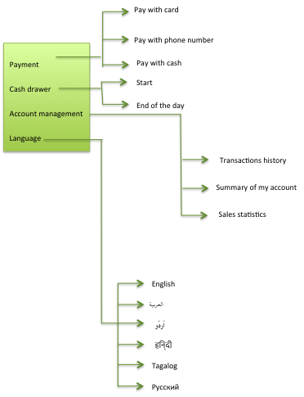

## How to use mCashier

### Conducting card payment

1. Open application, click on Payment, and select Pay with card. Make sure mCashier device is switched on and paired.

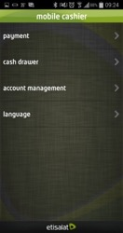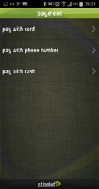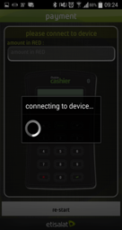

1. Enter amount due on Mobile cashier device and swipe the card. If this is a smart card (card with a chip on it) insert the card in the mCashier.

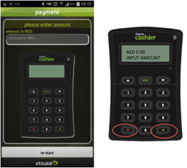

1. Pass mCashier device to the Customer and ask him to confirm transaction by entering his PIN
2. On the background Merchant mobile phone will request the Bank to authorize the transaction. If transaction is successful, the money is as good as on Merchant Bank account.
3. Merchant have an option to send a receipt to the customer via SMS or email directly from Merchant phone or print physical receipt upon customer request

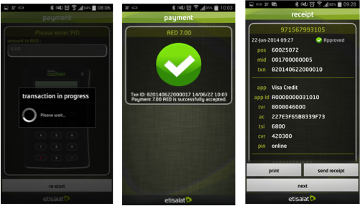

Important:

* Make sure the card is facing correct direction when Merchant swipe it or insert it in the reader
* If it is a swipe card the customer needs to sign on the mobile device

### Additional functionalities

Mobile cashier is much more than just card acceptance tool. Starting from recording cash transactions to complete control of account activity and sales performance. We took care of every small detail to help Merchant business perform more efficiently

### Accept Cash

To keep Merchant payment records in one place, Merchant can use mCashier to track cash and other future types of payments. There is no fee to accept other tender types. When Merchant accept cash, other tender types, mCashier does not process any funds and acts only as an organizational tool. Funds for these transactions will not be deposited by mCashier.

Before Merchant start accepting cash payments please start a day/shift with opening the cash drawer

### Cash Drawer treatment

To open a cash drawer please

Tap Cash Drawer –Start to record Merchant AED cash amount in Merchant drawer. Please note that if Merchant have cash amount from previous day/shift Merchant need to close it first before starting a new one.

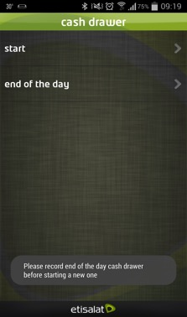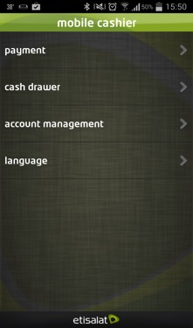

To start a new Cash Drawer please enter amount of cash Merchant have (can be 0 AED). Please enter password in order to proceed. Merchant can now accept cash payments. All the transactions will be fully traceable on the back end.

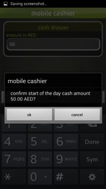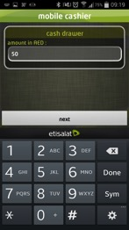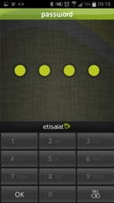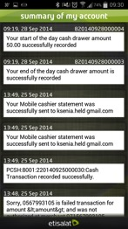

In order to close the cash drawer (between shifts or end of the day), please click on Cash Drawer- End of the day. Confirm the action and enter password. The action is documented on the back end and reflected on the Summary of Account

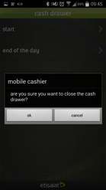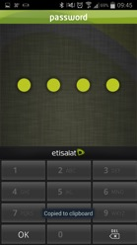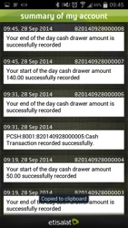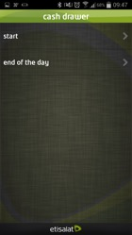

To record cash transactions:

* Select Payment-Pay with Cash
* Enter Amount Due on the phone
* Enter the Amount received from Customer. Application calculates change to be given to customer

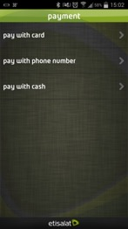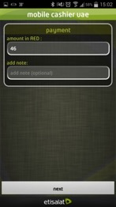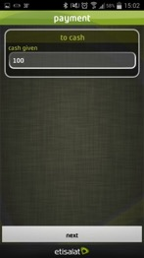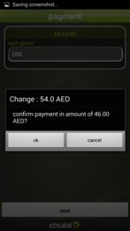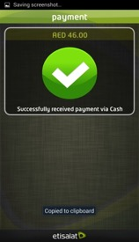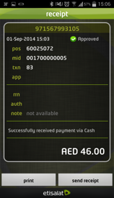

View complete account activity from the app

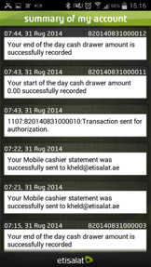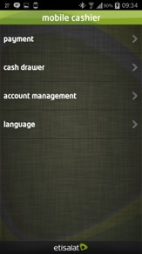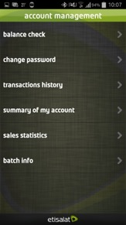

### Track payment activity.

Select Account Management- transaction history to trace/review or void particular transaction

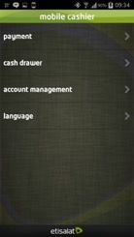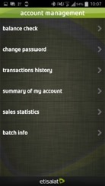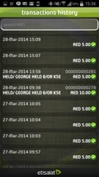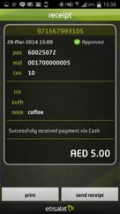

Discover new insights into Merchant business with Sales Statistics.  View detailed information about Merchant transactions or generate reports directly from the app or from online Merchant portal.

.

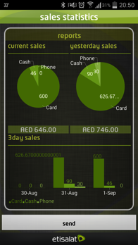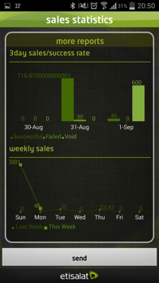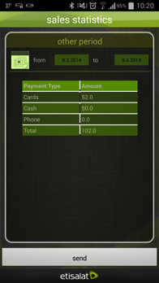

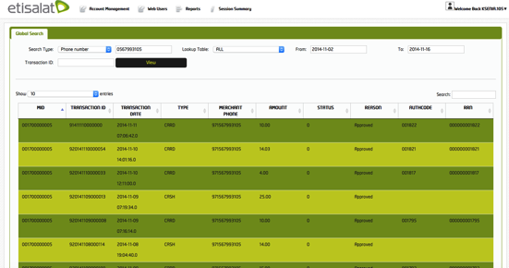

## Receipts

With every transaction, merchant can share an SMS, email, or printed receipt with the customers.

### Send Receipts

* Perform transaction
* Have Merchant customer enter their phone number or email address on the receipt screen.
* Send Receipt
* Check Receipt is sent in Account management- Summary of my account

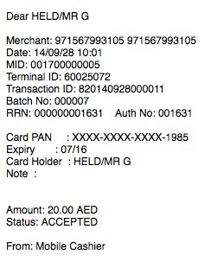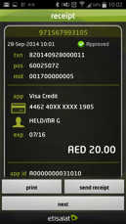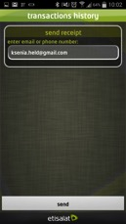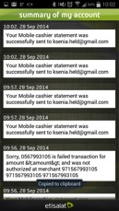

### Resend Receipts

Merchant can resend a receipt for a particular transaction from menu within the app. Just Navigate to Account Management-Transaction History, select particular transaction and clip Send to re-send the receipt via email or SMS or click on Print to physically print the receipt.

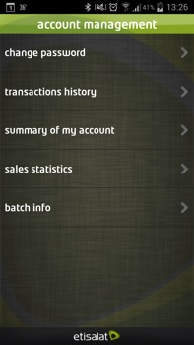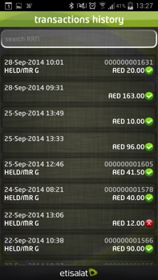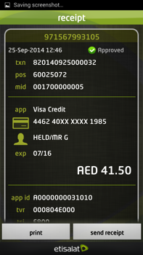

### Print receipts

If Merchant wants to print a receipt they need to buy Bluetooth printer (217 AED or 20 AED p/m)

How to connect printer (first time)

* Conduct payment transaction and choose Print,
* Make sure the Printer is properly charged, switched on, paper roll is properly inserted.
* Press feeding button to check the paper flow.
* Press Bluetooth button on the printer (blue light)

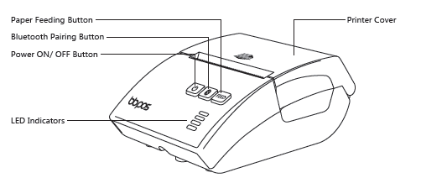

The pairing request will pop up on the mobile device. Please press ok.

Receipt is printed automatically

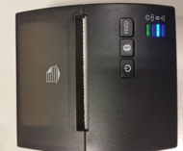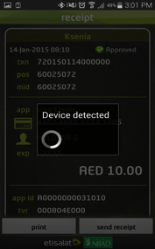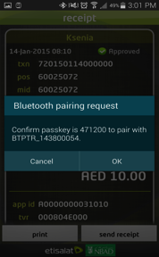

Subsequent use:

Press Power button on printer. Select Print on Receipt.

## Mobile Cashier application connectivity charges:

Please note that all mCashier transactions are Zero rated, Merchant will not be charged for conducting transactions, sending receipts or requesting reports (anything Merchant are doing within app is free of charge)

Please keep in mind that any data usage outside of the mCashier app (ie. web browsing, email, apps) will be chargeable according to Merchant plan rates.

### Multiple mCashier accounts

If Merchant has employees/Cashiers or multiple locations they can buy extra mCashier card readers and provision them as sub accounts. All proceeds from transactions will be deposited to account's linked bank account.

## Accepted Cards and Fees

### Fees and pricing

Mobile Cashier offers clear pricing so Merchant doesn't have to worry about a complicated fee structure and can focus on business. mCashier processes all cards with the same standard rate that will be communicated to merchant in the time of the contract sign off.

mCashier works with any local and most international issued cards bearing a Visa and MasterCard, logo including the following card types:

* 1. Credit
  2. Debit
  3. Gift
  4. Pre-Paid

### Bank Account and Deposits

mCashier follows standard deposit schedule, payments taken from  12am to 12am and will be credit the next day. That is all transactions done on 14th JAN from 12am to 12am will be capture and settled the on the 15th of JAN.

## Security

### Hardware

To protect mCashier account holders and their customers, all information our customers submit is encrypted to our servers, regardless of whether Merchant're using a public or private WiFi connection or a data service on the phone (such as 3G, 4G or EDGE).

mCashier complies with all required [PCI standards](https://www.pcisecuritystandards.org/). As per our Merchant Agreement and [Privacy Policy](https://squareup.com/legal/privacy), we will never sell information to third party vendors.

Square protects its systems with industry-leading technology and security controls, including:

mCahsier performs data encryption within the card reader at the moment of swipe.

mCashier software is developed using industry-standard security best practices.

Etisalat and NBAD employees act in accordance with security policies designed to keep Merchant data safe.

### Physical and Network Security

Fully encrypted: mCashier performs data encryption within the card reader at the moment of swipe.

Sensitive data is encrypted using industry-standard methods when stored on disk or transmitted over public networks.

Only standard, well-reviewed cryptographic protocols and message formats (such as SSL and PGP) are used when transferring data.

Symmetric cryptographic keys are required to be at least 128 bits long.

Security updates and patches are installed on servers and equipment in a timely fashion.

Security settings of applications and devices are tuned to ensure appropriate levels of protection.

Networks are strictly segregated according to security level. Modern, restrictive firewalls protect all connections between networks.

Card-processing systems [adhere to PCI Data Security Standard](https://www.pcisecuritystandards.org/security_standards/index.php) (PCI-DSS)

### Web and Client Application Security

Card numbers, magnetic stripe data, and security codes are not stored on mCashier client devices.

Applications developed in-house are subject to strict quality testing and security review.

Card-processing applications adhere to the [PCI Data Security Standard (PCI-DSS)](https://www.pcisecuritystandards.org/security_standards/index.php)

### Organizational Security

Access to sensitive data, including application data and cryptographic keys, is strictly controlled on a need-to-know basis.

Two-factor authentication and strong password controls are required for administrative access to systems.

Security systems and processes are tested on a regular basis by qualified internal and external teams.

All access to secure services and data is strictly logged, and audit logs are reviewed on a regular basis.

Security policies and procedures are carefully documented, and are reviewed on a regular basis.

Detailed incident response plans have been prepared to ensure proper protection of data in an emergency.

mCashier complies with the Payment Card Industry Data Security Standard (PCI DSS) on Merchant behalf so Merchant do not need to individually validate Merchant state of compliance.

The following are items that mCashier has addressed on Merchant behalf:

* Mobile Cashier does not retain payment card data on the mobile device or within the application.
* Mobile Cashier app used uses the mcashier card Reader to encrypt all card-present transactions at the point of swipe, pin entry so information remains encrypted throughout transmission from the reader, to the application, to mCashier platform and to NBAD server. All communications is secure whether connected to the Internet via wireless or cellular data network (EDGE, 3G or 4G.) or using SMS.
* mCashier provides an application that is secure by default allowing customers to focus on their business. There are no configurable security controls within the application.
* It does not require or permit remote connectivity to the application.
* If Merchant customers choose to provide an email address or phone number during an mCashier transaction, it will be used for a receipt only.

# FAQs:

### Q: Am I eligible to apply for mCashier?

A: mCashier is a product available to all registered UAE businesses. Merchant has to have an Etisalat SIM card (postpaid or Wasel) in order to use this service.

### Q: Who is offering mCashier service:

A: Etisalat is offering the service in partnership with NBAD

### Q: Is your service secure?

mCashier complies with all required [PCI standards](https://www.pcisecuritystandards.org/). Data is properly encrypted and Card numbers, magnetic stripe data, and security codes are not stored on mCashier client devices.

### Q: Do I need to have a bank account with NBAD in order to use this service?

A: No, it is not necessary to have account with NBAD. Please let us know your current bank account details. All proceeds from mCashier sales will go to specified account.

### Q: What card brands and card types do you accept?

A: mCashier works with any local and most international issued cards bearing a Visa and MasterCard, logo including the following card types:

1. Credit
2. Debit
3. Gift
4. Pre-Paid

### Q: What are your fees:

A:

* Card reader 299 upfront or 27 AED p/m on a year contract
* Printer is 217 upfront or 20 AED p/m on a year contract
* Merchant fee varies and is being communicated and agreed at the time of the contract signing ( usually 2.5%)

### Q: How does “Pay with Cash” option work?

A: mCashier provides you tool to record all tender types (Cash and Cards) to make your reconciliation and reporting process seamless. We will not collect and deposit cash on your behalf.

### Q: How ForEx rates are determined?

ForEx treatment for generic mCashier app

mCashier app has an option to accept cash payments in the following currencies:

1. 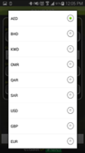US Dollars
2. Pound Sterling
3. Euro
4. Bahraini Dinar
5. Kuwaiti Dinar
6. Rial Omani
7. Qatari Rial
8. Saudi Riyal

Source: mCashier Platform will receive RSS feed from BUYING RATES posted on UAE Exchange site

<http://www.uaeexchange.com/uae-exchange-currency-rates/ae/urss>

Updates will be requested automatically by the app when performing “Start of Cash drawer” command

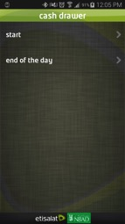

### Q: How does “Pay with phone number” works

A: This is future feature that will enable merchant to initiate payment request through Etisalat Mobile wallet solution.

### Q: What do I do to keep my mCashier devices functioning properly:

A: Every morning:

1. Switch on the Tablet
2. Switch on the mCashier card reader
3. Switch on Bluetooth printer
4. Start Cash Drawer with amount of Float money Merchant have (Can be 0 AED)

Every evening:

1. Switch off Tablet
2. Connect Tablet to the charger
3. Switch off mCashier card reader
4. Connect mCashier card reader to the charger
5. Switch off Bluetooth printer
6. Connect Bluetooth printer to the charger

Both devices are charged with mini USB (provided it a time of purchase)

### Q: Customer does not feel comfortable giving mobile phone number/email address for the electronic receipt

A: When customer provides email address or phone number during mCashier transaction, it will be used for a receipt and receipt only. Customer can always request the printed receipt.

### Q: Can I use any Bluetooth printer to print the receipt?

No, there is certain integration involved between mCashier application and MCashier printer in order to print the receipt. Any other Bluetooth printer will not work without prior integration.

### Q: Customer have not received receipt (via SMS or email)

A: Please check if the phone number/ email address has been entered correctly (go to Account management/Summary of my account for confirmation. Delay can be attributed to connectivity delay and handover between networks (Etisalat-Du) Please resend the receipt if required.

### Q: Why am I not receiving deposits?

A: Please contact NBAD call center number 02.4104888 call for all settlement related queries.

### Q: When will my money be deposited?

A: mCashier follows standard deposit schedule, payments taken from 12am to 12am and will be credited the next day (all transactions done on 14th JAN from 12am to 12am will be captured and settled the on the 15th of JAN)

### Q: I cannot sign in to my merchant web portal

A: Customer care representative will reset your password after answering some security questions.

### Q: Why can't I activate my account to accept payment cards?

A: You account might be in the inactive stage pending Bank approval. Once you receive notification that the bank has approved your application you will be able to start accepting payments

### Q: Where can I use mCashier?

You can use mCashier only in UAE. Service will be blocked in roaming

### Q: My card reader/printer is not working -where I can replace it.

A: Please visit Etisalat Business Center and do not forget to bring the warranty card (if device is still under warranty)

List of drop off points

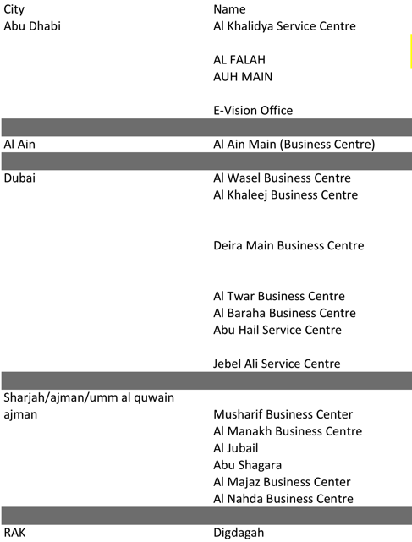

### Q: where do I get paper for printing receipts:

Your Bluetooth printer is using standard 57mm X 30 MM thermal rolls.



It is Merchant responsibility to source paper rolls

## Troubleshooting:

For the full list of errors and mobile devices tested compatibility please go to the attached file



## Delayed or Pending mCashier Activation

Etisalat will collect all required information from Merchant and send it to NBAD for account opening.

Merchant will receive notification that Merchant application has been forwarded to NBAD Bank for the review.

It will take Bank on average 24 to 48 hours to give the decision on the application.

During this time Merchant will not be able to use the mCashier service and process the payment even if Merchant bought the mCashier card reader from us.

Merchant will receive SMS notifying on the status of the application and containing the link to download application.

There might be unforeseen delays due to internal processes or incomplete information provided.

If Merchant have not heard from us for more than three (3) business days please call 8009111 (ES) or 8005800 (SMB) and we will be able to advise Merchant on the application status

## Password Troubleshooting

### Reset Merchant Password for the online mCashier portal

If Merchant has having trouble logging in to Merchant mCashier WEB Portal they should call CC 800 5800. Merchant will be asked number of security questions and login in /password will be re set and sent via SMS to Merchant’s phone. Please change it immediately.

### Reset Merchant Password in the App

If Merchant has trouble remembering Merchant password on the app they will call 8009111 (ES) or 8005800 (SMB). Merchant will be asked number of security questions and Merchant password will be re-set to default (1234). Merchant is advised to change it immediately.

To change Merchant password from the mCashier app click go to

Account management- change password

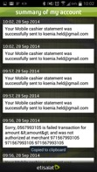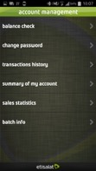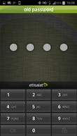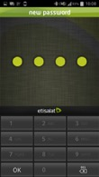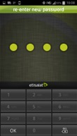

1

2

3

4

5

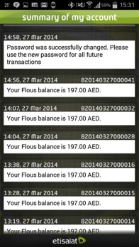

## mCashier card reader Troubleshooting

If Merchant card reader isn't working properly, please try the following tips:

1. Make sure the mCashier card reader is properly charged. To check the battery status:

* Switch the Card reader on
* Open mCashier application on the mobile device, click on the application menu (usually left button on the moble device), click on the Get device info
* The device info will be displayed inside the app, including battery stats, hardware and firmware version

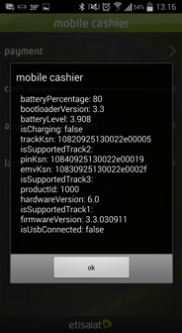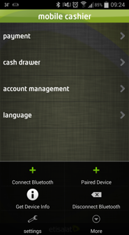

## Error: No device connected/Mobile app failed to start Bluetooth 2.0/Please pair the device first

For the first time use:

* Make sure mobile device supports Bluetooth version 2.1 and up.
* Make sure Mobile device has the Bluetooth switched on. Please double check by Switching Bluetooth on and off again.

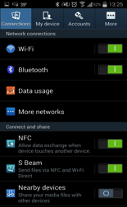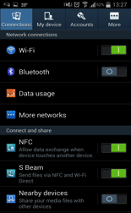

Please pair mCashier card reader with Mobile device.

* Lightly press on the power button on the mCashier card reader. The screen will boot and show STANDBY. Press on Bluetooth button until the blue light comes. Device will show BT Pairing.



* Open Etisalat Mobile Cashier application on Merchant Mobile phone. Select the application menu and Select “Connect new Device option”.



* Confirm the passkey on both mPOS device and mobile phone. Pairing is complete.



For the subsequent use:

* Click Disconnect Bluetooth on mCasher app
* Click Connect paired device

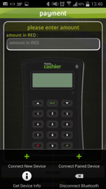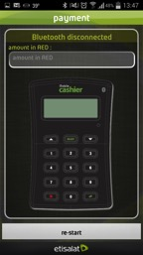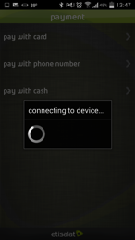

If this is not helping please unpair the devices and pair again (follow the first time installation guide)

* To unpair device please go to Setting click on the Bluetooth
* Select mCashier device in the Paired Devices section (device number should match the number printed on the back of device)

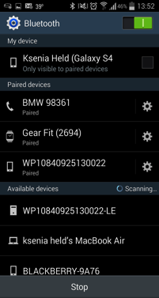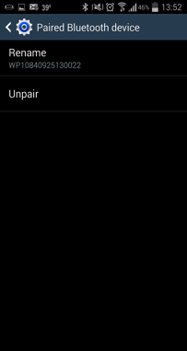

If no luck please force close the app/ Reboot the mobile device or even reinstall the mCashier app

For this please go to Menu-Settings- Application Manager-Click on Mobile cashier app-Force Stop

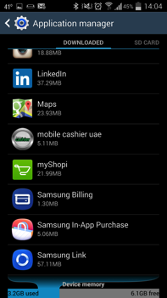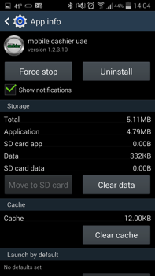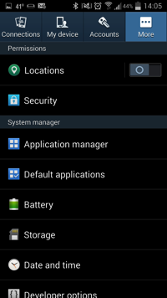

If nothing helped so far please uninstall the mCashier app from Merchant device and reinstall again.

For this please go to Menu-Settings- Application Manager-Click on Mobile cashier app-Uninstall



## Error: BAD SWIPE: Card reader cannot read/feel certain cards

* Make sure Merchant swipe/ insert card correctly.
* Make sure the Customer card is not damaged, request another card
* Make sure the mChashier device is only used for its intended purpose.

If the device is in fact faulty there is 12 months starting from the purchase date.

The warranty does not cover:

1. Disassembling or repairing outside Etisalat Business Centers
2. Any misuse or abuse form the Merchant
3. Liquid damage or burns from the Merchant
4. Scratches, breaks of plastic cover
5. Non-original accessories used with the device
6. Any modification in the warranty card or serial number
7. Repairing after warranty period

If Merchant thinks card reader is faulty, and it is under warranty, please bring it to the Etisalat Business Center.

## Troubleshoot Merchant Application performance

If Merchant run into trouble using the Mobile cashier Application, these tips will help Merchant quickly get back to accepting..

If Merchant notices a glitch with Merchant mobile device or from the app itself, try the following troubleshooting tips:

1. Make sure Merchant device supports 2.1 Bluetooth and it is switched on.
2. Make sure mCashier application is up to date (Merchant will receive notification if we are running update, please make sure Merchant keep Merchant application updated)

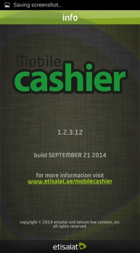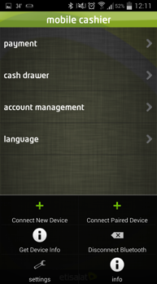

1. [Force quit the app](https://squareup.com/help/en-us/article/4992-app-and-account-troubleshooting#force-quit) on Merchant device
   * + Within "Settings," select "Application" and continue to "Manage Applications."
     + From here, Merchant will be able to select all running applications. Tap the Mobile Cashier App and then force quit the application

.

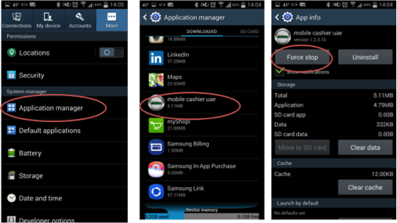

1. Turn mobile device off and on.
2. Delete and reinstall the application.

Deleting and reinstalling the app will have no impact on Merchant Mobile cashier account or completed payments, as Merchant data is safely stored on mCashier servers. Once Merchant deletes the app, Merchant can access all of Merchant account information by reinstalling it.

## Payment Troubleshooting

### Declined Cards

If a customer's card fails to authorize, Merchant will receive one of the following messages:

"Declined. Incorrect PIN."

“Declined. Not sufficient funds”

“Declined. Bank not supported by switch”

If Merchant customer has confirmed the card is valid and the transaction still results in a decline, the cardholder will need to contact the card-issuing bank for more information.

If the payment is successful, it will appear as a completed transaction immediately. Merchant can [confirm a payment was successful](https://squareup.com/help/en-us/article/5082-payment-troubleshooting#completed-payments) by checking Merchant "Transaction history" within the app or within the mCashier web Dashboard.

Note: A payment is not complete until Merchant’ve passed the signature screen and received notification that the payment was successful. If Merchant are unable to process the card in question, we recommend seeking another form of payment and having the cardholder contact their issuing bank for more information.

Keep in mind that declined cards may result in [pending charges](https://squareup.com/help/en-us/article/5082-payment-troubleshooting#pending-charge) on Merchant customer's bank statement, which should disappear in a few business days.

### Void Payment

You can void a payment before it is settled. Void is only successful if the electronic payment has not yet settled. Settlement occurs when the payment has been fully processed and the funds are transferred from the card network associations or the issuing bank to the merchant's bank account. How to do void?

Select the transaction you want to VOID (Account management-transaction history)

Right click on the menu button (hold till Void function appears)

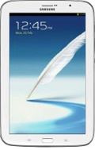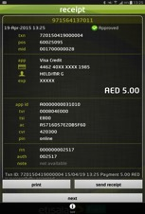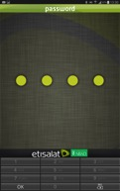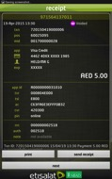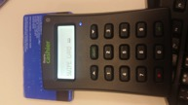

Make sure Card reader is switch on and you have the card that was used for this transaction

Application will ask you to swipe the card

Enter supervisor password

Successful void confirmation

### Handling refund

Refund is performed after the settlement is done

Please send an official email with all the details to NBAD operations team. The amount is recovered automatically from the next day’s transactions.

To: Priya Krishnamoorthy(Team Leader - Acquiring Chargeback) [Priya.Krishnamoorthy@nbad.com](mailto:Priya.Krishnamoorthy@nbad.com)

CC: Asim Ahmed (Manager - Alternate Channels & Service Support)[Asim.Ahmed@nbad.com](mailto:Asim.Ahmed@nbad.com) and Mary Grace Adelantar Macatangay (mPos Channel Relationship Officers) [Mary.Macatangay@nbad.com](mailto:Mary.Macatangay@nbad.com)

Please state transaction details (transaction ID, amount),

Error: Wrong pin entered-

Customer wants to cancel and enter new. Press cancel, device will show Cancel and Terminated. Go back by clicking Back arrow on the Tablet. Start transaction from the beginning

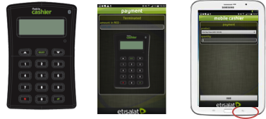

Error: Wrong amount /wrong pass type was selected – want to cancel. Press cancel, device will show Cancel and Terminated. Go back by clicking Back arrow on the Tablet. Start transaction from the beginning

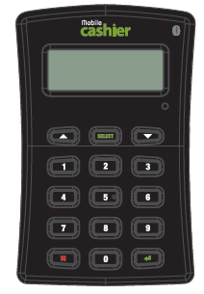

AED 460

X DECLINE --ACCEPT

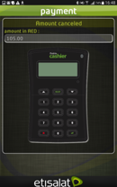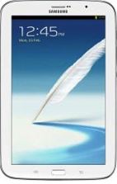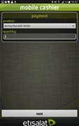

"Declined. Incorrect PIN."

“Declined. Not sufficient funds”

“Declined. Bank not supported by switch”

If Merchant customer has confirmed the card is valid and the transaction still results in a decline, the cardholder will need to contact the card-issuing bank for more information.

Note: A payment is not complete until Merchant’ve passed the signature screen and received notification that the payment was successful. If Merchant are unable to process the card in question, we recommend seeking another form of payment and having the cardholder contact their issuing bank for more information.

### Customer have not received receipt via SMS/email

Please make sure Merchant enter the correct phone number/email address. The way to check is to go to Account management-Summary of my account and confirm the phone number added

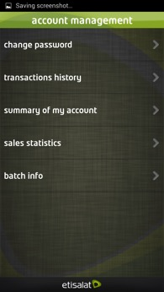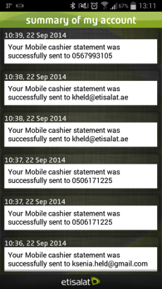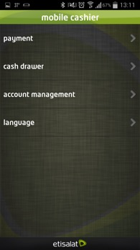

### Report was not delivered to requested email address.

Report will be sent to the registered email address. The way to check is to go to Account management-Summary of my account and Check the entry



### Transaction Connectivity Disruption

It is very unlikely that the transaction will not be able to get completed due to connectivity. Even if Merchant are multitasking and Merchant happen to receive a call/ sms during the transaction it will not get disrupted/cancelled.

mCashier can perform transactions using different channels:

* WI-FI connection
* Data connection (3G, 4G or EDGE)
* SMS

Wi-Fi connectivity will result in slight faster processing experience.

In the areas of poor data coverage the application will recognize it and fall back to SMS as the most reliable mean of connectivity.

Transport media is currently set to Internet and can be manually switched to SMS from application.

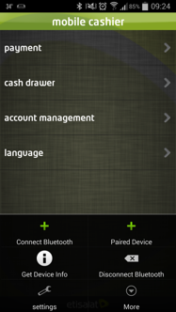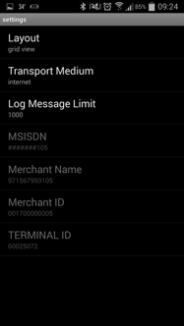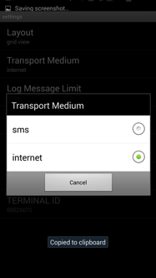

### Pending Charges

If a payment is canceled or interrupted, Merchant customer may see a pending transaction on their card statement. It may look like the charge has been posted to their account, but it should disappear after a few business days.

mCashier sends a void notification to the bank as soon as a payment becomes voided. This notification informs the bank that mCashier will not be capturing the funds in question.

A good way to confirm this is by checking Merchant [Activity](https://squareup.com/help/en-us/article/5072-summaries-and-reports-with-square-register#viewing-your-sales-history) within the app or Merchant [Transactions](https://squareup.com/dashboard/sales/transactions) online. If the payment does not show up in Merchant history, but appears on a customer's card statement, this is a sign that Merchant customer is seeing a pending transaction and not an actual charge.

## 

## Troubleshooting Merchant Bluetooth Printer performance

### Error: Device is not switching on

* Please make sure the device is charged. Allow sufficient time for charging.
* Try pressing power button for a bit longer.
* If everything else fails, please bring device to Etisalat Business Center for check/replacement.



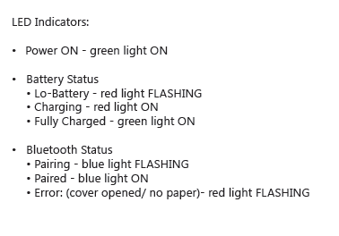

### Error: Printer is not getting paired with mobile device.

* Please check that your current device has Bluetooth 2.1 and up.
* Please Force stop the Mobile cashier app (go to settings- applications- force stop)
* Restart the phone

If everything fails please let us know the model of the device and we will test or ask you to come for further investigation

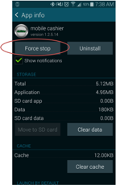

### Error: Device is not printing.

* Please check if device is properly paired with the phone.
* Check the serial number of the device and paired device on the phone
* Unpair device and pair again
* Force stop mCashier app
* Restart the phone

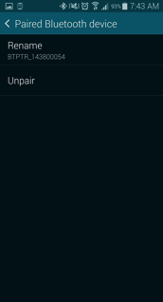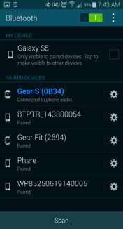

If everything fails please let us know the model of the device and we will test or ask you to come for further investigation

### Error: Bad printing quality

Please charge the printer properly. Depleted power supply results in poor quality printing

### Error: Receipt is not coming smoothly, paper jam

Please check the size of the paper in the paper tin: 57X30 mm thermal paper

Please remove extra layers of paper in order to fit the paper in the tin.

### Error: OS on device is < 2.3.3 ( GingerBread)

The mCashier app is designed to run on Android devices version OS 2.3.3 (GingerBread) and up, Bluetooth v 2.1 and up

To check Merchant Android software version number, go to Settings app > About device > Android version.



The process to update the software on each Android device is different. If Merchant device is not running 2.3 or higher, please check with phone manufacturer or carrier for upgrades.